>> Switching to Non-parametric statistical tests therefore no need for Q-Q plots and tests for normality.

**Scheirer–Ray–Hare test (non-parametric alternative to two-way ANOVA)**

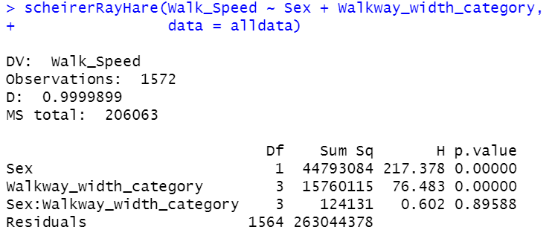

**Wilcoxon–Mann–Whitney test (non-parametric alternative to T-test)**

